**Variable : Age Range (Ratio)**

Average age is 27 years (26.85). Average age is not particularly relevant to

The dispersion of age is more relevant.

Summary Statistics

Max value: 17 Minimum value: 65 Range : 48 years

Skewness: 1.741 Kurtosis value: 1.930

The Skew value is greater than 1: Very positively skewed. This means that there is a majority of people in the lower age brackets. (i.e. mass of the distribution is concentrated to the left. It has relatively few high values.)

The kurtosis value is greater than 1 : Peaked. (leptokurtic)

Age follows a peaked, positively skewed distribution. Therefore it is not normally distributed.The variable “age” is not normally distributed, so should use the median and IQR range

[Median age 22 , Q1 = 22 , Q3 = 27.75 , IQR = 6.75]

A visual inspection of the dataset implies that a substantial proportion are in their twenties. This is confirmed by the Skew/Kurtosis.

Also 91 of the sample are university students. (is this representative of general population?)

Nobody over 65 is in sample 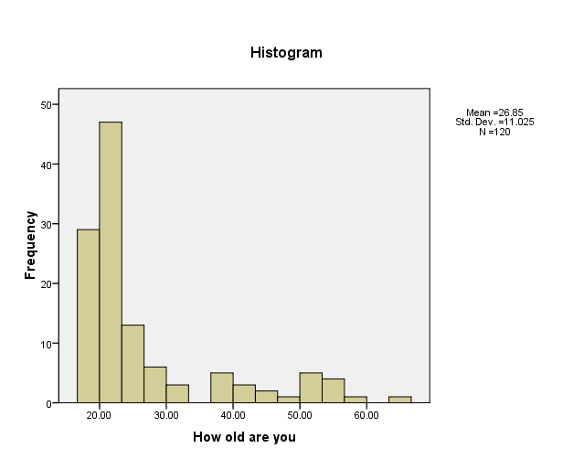

**Variable: Sex (Categorical)**

The mean value of the age variable is 54.63% this means that there neither sex is disproportionaltey represented in the same.

(good split between males and females, but too many 20-somethings to be representative)

**Variables: Education (Categorical)**

116 completed secondary school ( the four that didn’t are older than 39)

91 (75.83%) are university students 35 (29.16%) are graduates

4 have not completed Secondary (03.33%)

Larger sample is desirable: but with more representation from older people.

**Suggestion:** no mention of whether or not the person is from a urban or rural area. Might include this in a future study ??

**Variable: RWA ( Right Wing authoritarian) (Ratio)**

Normally distributed. [Kurtosis approx = 1, Skew approx = 0]

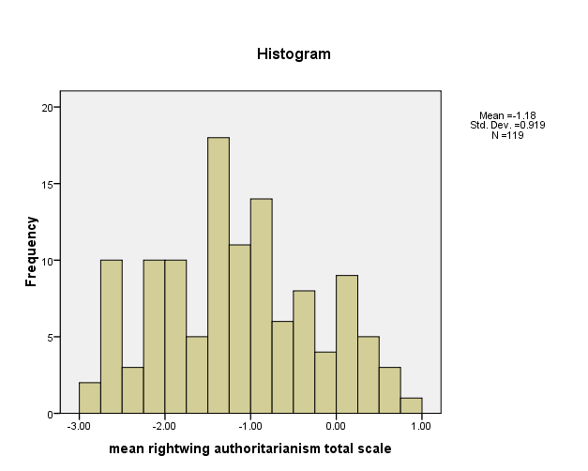

**SYNTAX CODE**

Syntax code to create previous outputs .

( **File > New >Syntax** , paste in code pieces below, then press the arrow in the menu bar)

examine RWA.tot

/plot boxplot stemleaf histogram

/percentiles(5,10,25,50,75,90,95,99).

examine Age

/plot boxplot stemleaf histogram

/percentiles(5,10,25,50,75,90,95,99).